Otford Tennis Club
OTFORD LAWN TENNIS CLUB
Autumn 2016 Newsletter

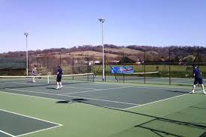
Message from the Committee
As the nights become longer it is time to reflect on the summer’s tennis and what lies ahead for the rest of the year and beyond. At the beginning of the summer we held the Wimbledon ballot and Open Day in glorious sunshine in what was otherwise a cool and wet early start to the summer. Over the summer months members participated actively in the regular Tuesday and Thursday night as well as Sunday morning sessions. In early September the club tournament culminated in a successful Finals’ Day for which there is a short report below. Looking ahead we hope that members will continue to participate actively and that we can grow the membership during 2017 and existing members are urged to try and recruit friends and acquaintances to try out the club with a view of becoming members. We believe the subscriptions offer outstanding value compared to competing clubs and other activities in the local area. There are reduced subscriptions available for the rest of this year (see below for details). The committee would also like to thank all those who have been involved in the coaching programme that has proved a great success this year.

Court maintenance
It is a while since the top 2 courts have been resurfaced and all those who remember what they were like before will appreciate how much it has improved the playing experience for members. With this in mind the committee agreed that the bottom court should be resurfaced this autumn. Quotes have already been obtained so work should commence fairly soon and when it does the necessary connections and base for installation of floodlights at a later date would also be installed.

Wimbledon Ballot
The time has now come to opt-in with the LTA in order to be eligible for the club’s Wimbledon ballot in 2017. In 2015 the rules of the ballot changed and meant the club’s allocation of tickets for the tournament was proportional to the number of members who registered as BTM members on the LTA website. When we hold the ballot in the spring of next year only those members who have registered will be eligible for tickets in the ballot so we urge you to register. The more members that register the higher will be the allocation of tickets for the club.
To opt-in members have to simply log in to their Members Area and click OPT IN.

Coaching
As mentioned above the coaching sessions have been very successful. However, this is a reminder that the coaches also offer private tennis lessons, holiday camps, restringing and equipment advice and discounts at The Racquet Academy in Otford (next to One Stop). If you would like further details please call 01959 523377 or email sevenoakstennis@btinternet.com. You can also contact Alison Dykes, a member of the committee, at alison.dykes@lwcdial.net who can provide you with an application form and further information.

Club Playing Sessions
The regular club playing sessions take place on Tuesday and Thursday nights at 7.30pm and Sunday morning at 9.30am, weather permitting. There is an email that is circulated that helps arrange the sessions and ensure there are enough players to make it worthwhile. If you are not on the email list please let someone on the committee know and we can easily add you to the list. As the Tuesday night session has become more popular the committee has proposed that it should be reserved for mixed doubles and, for ladies who prefer to play with their own sex, a club night would be reserved for them after the Wednesday coaching session finishes at around 8.30pm. If anyone has comments or further suggestions on this topic please let me know for further deliberation.

Club Tournament
The Finals’ Day took place in mixed weather and some rain meant that the mixed doubles final was not completed until the following week. However, the day still contained plenty of competitive tennis with the winners as follows with some commentary and photos below:
Mens’ singles: Matt Jackson
Ladies’ singles: Julie Hummersone
Mens’ doubles: Matt Jackson and Owen Thomas
Ladies’ doubles: Anne Waite and Julie Hummersone
Mixed doubles: Matt Jackson and Anne Waite

Finals Day arrived with a clear start but rain on the horizons so the men's singles got underway with some fantastic points coming from both Owen and Matt. Matt ended up the victor in the first of his 3 finals. The ladies singles were evenly matched with Alison and Julie having some mammoth games that had more deuces than a Robinsons factory! After a tight match Julie just snuck ahead and claimed the trophy. The men's doubles saw Matt and Owen claiming victory over Kevin and Tim in a testosterone filled final! The ladies doubles was a far more serene match and had the ladies calling for an umpire when Alison put so much spin on a shot it bounced the other side of the net and then came back her side winning Alison and Stella the point, but after a short break for the rain Julie and Anne won the day. With still one match to play the Prosecco had to sit in the fridge a while longer! So the mixed doubles started amidst a slight drizzle with Kevin and Julie taking on Anne and Matt - with both Julie and Matt looking for a hat trick of trophies the game began in earnest. Unfortunately the rain became too much so the match was halted at 1 set all with Anne & Matt leading Julie & Kevin 5-4 in the 3rd set with Kevin to serve next. When the match was concluded the following weekend Anne and Matt just pipped it leaving Matt with a trip to Homebase in search of a new shelf for all 3 trophies.

On Finals day the prosecco was eventually consumed, along with salmon and egg sandwiches, sausage rolls and cakes, with a special birthday cake for Tim and a hearty rendition of Happy Birthday was sung by all who attended. Thanks to Anne and Nicola for laying on such a sumptuous spread.

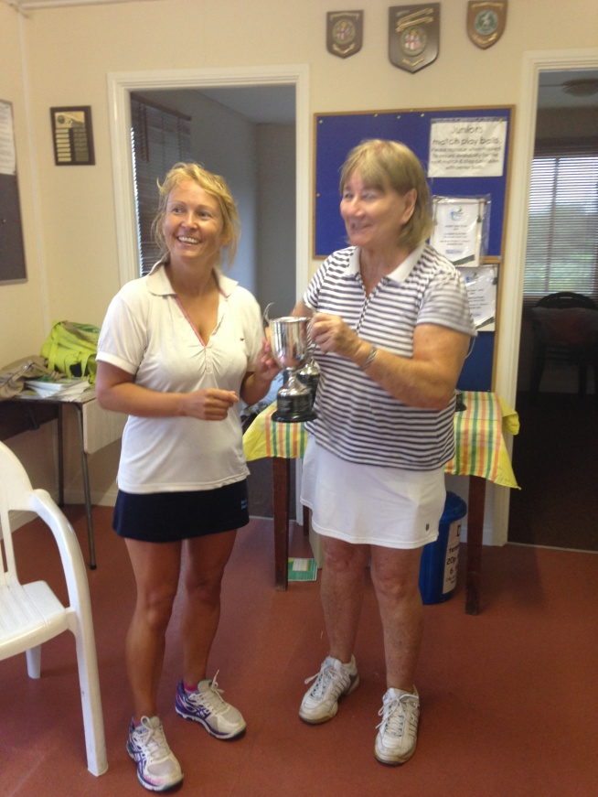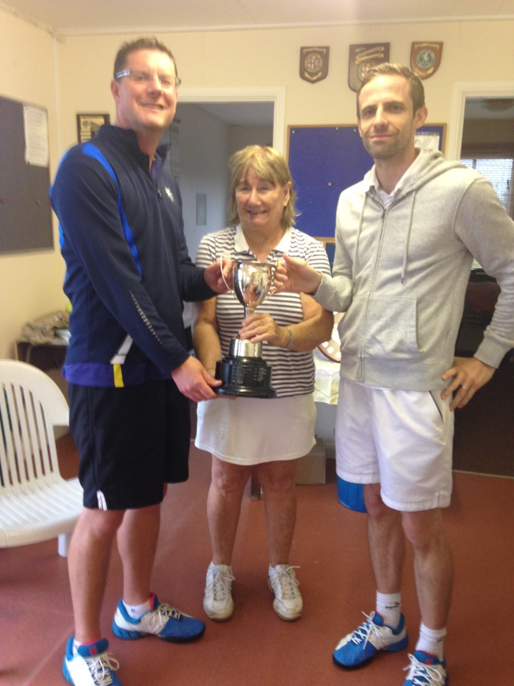
Ladies doubles winners Mens doubles winners

Membership Subscriptions
It was decided at the committee meeting to reduce the fees for the remainder of the club’s financial year to March 2017. As mentioned in the introductory paragraph please mention this offer to any friends who may be interested in giving the club a try before fully committing. The revised subscription fees are as follows:

2016 reduced subscriptions (until March 2017)
Full member Full adult membership, weekdays, weekends, & evenings £55 Midweek member Adult membership, Mon-Fri until 6pm only £40
Juniors £15
Family membership For 2 full adult membership and 2 children up to the age of 18 £100
Christmas Dinner
There will be a social club dinner on20th Tuesday December so please keep it free. The dinner will be at the Cote restaurant, as last year, which is in London Road in Sevenoaks. If you would like to come please email our Chairman, Paul Byrne: (paul.byrne@cavendishmunro.com)

Entrance to the club
The handle to the door providing entrance to the club was removed by vandals some months ago but the gate can easily be opened and locked using the key given to members. However, it has been noted that the door has been left unlocked on several occasions recently. Please can you ensure it is locked if you are the last to leave the courts.

Ted Scott (Secretary) ted-scott@btconnect.com

